Welcome back!
We hope you had a lovely holiday and a big thankyou for sending the children back looking so smart in their uniforms. A big welcome to our new Reception children who are settling in well. We also welcome a new member of staff this term, Miss Lester, who is teaching Y5.
…………………………………………………………………………………………………………………………………………
Applying for a school place - deadlines
If your child is currently in Y6 you need to apply for a secondary school place by 31st October 2016. The easiest way to apply is online at www.blackpool.gov.uk. If you miss the deadline you may not get the choice of school that you want so it is very important that you make the application in time.
If your child was born between 1st September 2012 and 31st August 2013 you need to apply for a primary school place by 15th January 2017. More information can be found at www.blackpool.gov.uk.
………………………………………………………………………………………………………………………………….
Academy
You will have received the letter just before the summer holiday informing you that the Governors, after consultation, have decided to go ahead with conversion to an academy as part of Fylde Coast Academy Trust. We are very pleased with the decision as we feel being part of the Trust is definitely the best way forward. At the moment the application to convert is being considered by the DfE and we will keep you updated with progress in future newsletters.
………………………………………………………………………………………………………………………………………….
Holiday dates
Holiday dates for this year are at the end of this newsletter. They are also available on the school website. If you ever need to search online for holiday dates please be aware that there are websites out there that say they have the holiday dates for all schools, but many schools have found the dates are incorrect. Please always use the school website (address at the top of this newsletter) to make sure you have the correct dates. Also please remember that holidays in term time can only be authorized in exceptional circumstances. You can get a form from the school office to ask for your circumstances to be considered but please be aware the law has not changed and unauthorized holidays can still lead to a penalty notice.
………………………………………………………………………………………………………………………………………….
Exciting playground developments
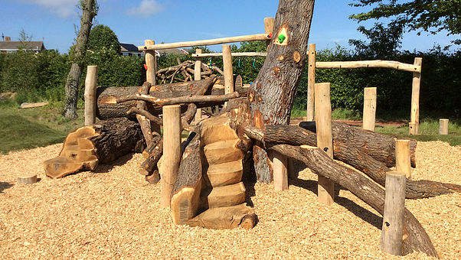
Work will begin later this month on an exciting new play area for the KS2 children. The fencing at the front of school (next to the Children’s Centre garden) will be moved and on the grass area there will be a large new climbing structure built that the children will be able to use at playtimes and lunchtimes. It will look similar to this picture. This has been funded partly from buildings money that we have been saving up, and partly from the School Fund that you have generously contributed to through Fairs, non-uniform days etc. We are also having a reading area installed by the tree in the playground. This is the latest phase in our plans to make playtimes fun for the children and we are very excited to see it take shape.
……………………………………………………………………………………………………………………………………………

Fluoridated milk
You will have received a letter last week about the new scheme to introduce milk with added fluoride in Blackpool primary schools. It is planned for this to begin after October half term. It will be offered free to children from Y1 up as part of the existing school breakfast scheme and there will be no cost to parents. Please can you complete and return the leaflet you will have received with the letter as soon as possible, to say whether you wish your child to have fluoridated milk, ordinary milk, or no milk.
………………………………………………………………………………………………………………………………………..
Free School Meals and Pupil Premium
Pupil Premium is funding that is paid to the school based on the number of children eligible for Free School Meals. All children in Reception, Y1 and Y2 are now entitled to a free school meal; however if their parents do not register the school does not receive the funding. This money is very important to the school as we use it to pay for speech therapy, psychology services, and extra staff so we can have smaller classes. (There is a full list of how we spend the money on the website). If you think you meet the criteria for Free School Meals, please can you register on https://www.blackpool.gov.uk/Residents/Benefits/Forms/Helpwithfreeschoolmeals.aspx
to make sure the school doesn’t lose out.
…………………………………………………………………………………………
Important dates for your calendar
w/b 19th Sept | National Coding Week – watch out for events taking place in school
Friday 23rd Sept | Jeans for Genes Day – come to school in your jeans
Thursday 29th September at 3:30 | PTFA meeting
Wednesday 12th October | Harvest Festival
Friday 14th October | School Photos (individual)
Wednesday 19th October | Book Fair arrives in school
Wednesday 26th October | Parents’ Evening
Friday 28th October | Break up for half term
Tuesday 8th November | Return to school

Children’s Centre news

Please note the Next Steps group is now running in the Children's Centre training room on a WEDNESDAY not a Tuesday from 10am to 11.30am. All children from just walking to about 30 months welcome. This is a 'next step' to Baby Club.
NEW! Baby Yoga from Thursday 15th September for five weeks. A Better Start funded activity, for babies from 10 weeks to becoming mobile. Promotes bonding, co-ordination and gentle exercise for you and baby. Mums and dads most welcome! Delivered by J'adore Mama. Booking essential through the Children's Centre.

Saturday 17th September from 10.30- 3pm A special fun planning and consultation event to find out what you want for children with the Mereside at Play project. With hands-on workshops and play experts to explore the outdoors. Lunch and refreshments all free! Booking is absolutely essential for catering purposes. Provided by Left Coast.

Find out all about what's on by collecting a timetable from the reception in the Children's Centre. Or phone 01253 839739 for more information.
HOLIDAYS 2016-17
Term | School closes at 3.15 pm on these days (unless stated otherwise) | School re-opens at 8.45am on these days
Summer 2016 |  | Monday 5th September 2016
Autumn Half Term 2016 | Friday 28th October 2016 | Tuesday 8th November 2016
Christmas 2016 | Thursday 22nd December 2016  (2pm close) | Monday 9th January 2017
Spring Half Term 2017 | Friday 10th February 2017 | Monday 20th February 2016
Easter 2017 | Friday 7th April 2017  (2pm close) | Tuesday 18th April 2017
May Day 2017 | Monday 1st May 2017
Summer Half Term 2016  2 WEEKS | Friday 26th May 2017 | Monday 12th June 2017
Summer 2016 | Thursday 20th July 2017  (2pm close)

