Mereside School Offer

Our SENCO is:
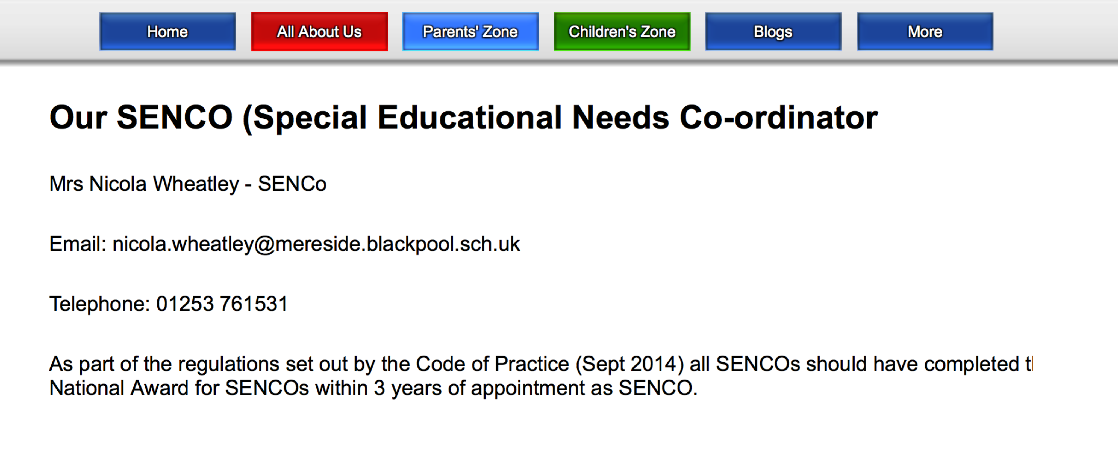

Mrs Nicola Wheatley – SENCo
Miss Sarah Smith – Assistant SENCo

Email: senco@mereside.blackpool.sch.uk

The SEND provision provided by the school including any support provided in relation to learning or the curriculum
All teachers at Mereside Primary School are teachers of children with special educational needs. They plan and deliver appropriately differentiated lessons according to the needs of individual children. All pupils are monitored and assessed through the schools assessment cycle to ensure that they are making appropriate progress.

Support Assistants are deployed to each class to provide support to all children under the direction and planning of the teachers. This support can take place as small groups, 1:1 support or intervention groups outside of the classroom. The SEN plan-do-review process in school is used to outline specific interventions and resources for individual pupils who require support. All staff have regular access to continuous professional development and relevant training, enhancing their skills to support individuals and groups of children.

All teachers are able to seek advice and strategies to support children’s learning from the commissioned speech and language therapists and an Educational Psychologist.

The arrangements that the school has for identifying those with Special Educational Needs and the process for informing and consulting with parents.
For children starting our nursery or reception class, our school works closely with other pre school settings to ensure a smooth transition, and that any additional needs your child may have are planned for. Foundation stage staff will complete visits to a child’s previous setting, if your child has previously not attended a nursery or has additional needs, you will be offered a home visit for staff to get to know your child and family, if needed the SENCO will also visit.

For children entering other year groups during the school year (non routine admissions) visits to school are arranged. The SENCo completes the admissions forms with you and will discuss any additional needs, allergies or family circumstances that you may feel school need to be aware of. The SENCO will then liaise with your child’s previous school to establish if any adjustments or specialist provision is required to support your child. Information will be then shared with relevant staff in school. Initial assessments will then take place once your child starts school to inform class teachers planning and interventions if required.

In preparation for your child’s progression to high school, in the summer term of year 6, the Year 6 teacher and in some cases the SENCO will discuss individual pupils with the SENCO or designated member of staff from the high school to ensure a smooth transition.
All children have the opportunity to spend ‘taster’ days at their allocated secondary school. Additional visits are planned for any children who require them in order to familiarise themselves with the new school environment.

Each term teacher’s make assessments on children’s learning, the results of which are discussed at pupil progress meetings between the class teacher and a senior leader in school. If a child is discussed due to them not making expected progress despite in class differentiation, interventions will be discussed and implemented. If in cases they continue to make limited progress, the class teacher will refer them to the SENCo and in some cases it may be appropriate for school to seek advice from outside agencies, in these cases parental consent will always be sought.

There may be other times throughout the year when teachers have concerns regarding a child who may have or develop an additional need. In this case they will discuss concerns initially with yourself to see what support can be put in within the classroom at through home support, if this support still does not improve the situation the class teacher will meet with the SENCO, who will in turn invite parents in to discuss a plan of action.

All parents have an opportunity to attend parents evening twice yearly and are provided with a written progress report at the end of the year. The SENCO and speech and language therapist is available in addition to the class teacher on these occasions to meet with parents.

The SENCO and class teachers are also available at other times throughout the year to discuss any concerns you may have, a mutually convenient time will be arranged for the meeting and if appropriate other professionals maybe invited to attend.

How the school develops its overall teaching and adapts its curriculum to ensure that teachers can include pupils with Special Educational Needs
At Mereside Primary School, we have high expectations for all, recognising all educational achievement, and providing an inclusive-learning environment that meets the needs of all children, enabling them to reach their true potential. Our assessment of children’s learning is paramount, allowing staff to teach and assess the individual child’s learning needs.

Our staff use a range of evidence for teacher assessments that confirm what the children can do over a period of time. A learning environment is created in our school whereby children are empowered to develop independence, and understand what they need to do to improve in their learning. Teaching staff use a range of teaching resources that support and extend children’s learning; children are taught how to use these resources themselves to foster independent and collaborative learning. Clear learning objectives and success criteria are identified for individual pupils, creating personalised learning. Our pupils and staff are fully involved in deciding next steps in learning. Our marking policy celebrates children’s successes and also identifies next steps. Our pupils and staff practice self and peer assessment, enabling children to have greater influence in directing their own learning paths.

Our Senior Leadership Team (SLT) and subject leaders ensure that teaching observations are undertaken on a regular basis and that teaching staff are consistent in employing our teaching and learning policy. This approach enhances the teaching and learning of the children by assisting in the monitoring of our school’s provision and progress, enabling us to plan for improvement. Termly pupil progress meetings between teaching staff and SLT assist in identifying children’s specific learning needs and any subsequent interventions that may be needed or planned.

How progress towards particular outcomes are measured and reviewed
Pupils are assessed three times a year and then discussed at termly pupil progress meetings whereby staff are accountable for results and progress made.

The Senior Leadership Team (SLT), SENCo and the Class Teacher analyse the data looking for anomalies, concerns or areas to celebrate. Core groups of children are scrutinised, these include groups such as: LAC (those in local authority care) FSM (Free School Meals) EAL (English as an Additional Language) SEN (Special Educational Needs) and G&T (Gifted and Talented).

A professional discussion takes place in such meeting. Staff will look at the steps that need to be taken in order to support a child or group of children who are not achieving their targets or a child who is exceeding their targets.

The Senior Leadership Team will work with the class teacher and support assistants to look at the intervention that needs to be put in place in order to improve the outcomes for each individual. Action plans and targets will be set and closely monitored. We set challenging targets based on where your child is currently working. These targets may be around their literacy, numeracy, social and emotional, speech, language and communication needs or working towards independence.

The transition process / arrangements that the school makes for pupils entering and leaving the school
Children begin our Reception class the academic year when their 5th birthday falls between 1st September and 31st August. We strongly encourage visits to our school prior to applying for a place, to look around, meet staff and hear about the life and work of our school. Open days are held and open to any parents of children from age 3 upwards. An induction meeting is also held for parents of Reception children in the summer term prior to the September start, the SENCO is available to meet and discuss any concerns parents may have.
Children may be admitted to other year groups if places are available throughout the school year. Applications for places are made to the local authority who will then liaise with school to discuss places. If a place is available, the admissions team will issue a letter confirming this and they will notify school that the place has been offered. As soon as school receive confirmation, you will receive a call from the school SENCo to organise an induction meeting.
For children in Year 6 we always seek to make the move between primary & secondary school as successful as possible so that you and your child are not feeling anxious about anything over the longer summer break. To support this all children have the opportunity to spend ‘taster’ days at their allocated secondary school. Additional visits are planned for any children who require them in order to familiarise themselves with the new school environment. We work closely with two main high schools with visits starting early in Year six for targeted pupils.

How the school secures additional services and the names and contact details of those services
The SENCO can make referrals for individual children to specialists both within the local authority and private companies. This is to gain advice to support children with specific needs such as speech, language and communication, visual and hearing impairments, autistic spectrum disorder (ASD), emotional and wellbeing difficulties. When a joint decision (between you and school) is made to make a referral the SENCO will complete the referral forms and send them to the relevant agency. Once receiving the referrals, the professionals will make contact with school or yourselves to plan meetings and discuss next steps.

Contact details of Support Services.
Wendy Thorley Educational Psychologist
SEND Team/Educational Psychology Service
Post to: Blackpool Council | PO Box 4 | Blackpool | FY1 1NA
T:01253 476616

Dr Zoe Owen
Educational Psychologist
Acorn Psychology
Business First Centre, Davyfield Road, Blackburn, BB1 2QY
Office: 01254 686 397

Mrs Claire Watson
Specialist Speech and Language Therapist
Communicate
Office telephone: 01253 462123
Facebook: CommunicateSlt
Twitter: @CommunicateSltCIC

Mrs Laura Cooper
Specialist Speech and Language Therapist
Communicate
Office telephone: 01253 462123

Lisa Carlton
Educational Diversity Outreach Worker
Educational Diversity | Outreach Team| Blackpool

Janette Dickin
Behaviour Advisory Teacher
Educational Diversity | Outreach Team| Blackpool

How the effectiveness of special educational provision is assessed, evaluated and reviewed including information about how children, YP and their parents take part in this.
Pupil’s progress is discussed at the termly pupil progress meetings and interventions are discussed and evaluated to assess the impact they have had on a child’s progress.

For children with a statement of special educational needs an annual review is held and led by the SENCO, parents and relevant professionals are invited to the meeting. There is opportunity before the meeting for all to record in writing their thoughts which will be discussed at the meeting. The child’s views are also sought before the meeting and if appropriate the child will be invited to attend part of the meeting.

For some other children that require additional support in order to make progress, plan-do-review meetings are held with relevant professionals and school staff to discuss progress and set targets.

How facilities that are available can be accessed by children and YP with SEN
Our school building is spacious, light and calming providing all children with a secure and comfortable learning environment.

Additional needs of individual children are assessed and if they require specialist resources, the school will request the most relevant assessment and advice and will then look into accessing the required equipment. Examples of these resources include a wobble cushion or enlarged text for visually impaired pupils.
Information about the expertise and training of staff in relation to children and YP with SEN and how specialist expertise will be secured/
All staff have access to relevant training to support the needs of the school and to enhance their own professional development.
After training staff feed back to their colleagues, usually via staff meetings and specific teaching assistant Meetings.

The SENCo and Reception teacher have gained Level 4 in speech, language and communication difficulties. Staff frequently receive training on speech, language and communication difficulties in staff meetings.

We have a lead support assistant trained in speech and language techniques who works closely with our speech and language therapist and supports colleagues with speech and language throughout school.

We have a member of staff trained as a moderator for the Local Authority.

We have four specialist behaviour support assistants and a behaviour SERF teacher.

Teachers from our school are involved in a number of outside projects in Maths, Literacy and Computing.

We have a member of staff trained in ABC (Attention, Balance and Co-ordination). This helps support children with co-ordination difficulties.

The SENCO has completed the National Qualification for SEN leadership and modules towards a masters covering Dyslexia and Autism.

All our Teaching Assistants have had training in delivering reading and spelling /phonics programs and these sessions take place on a daily basis.

We have a specialist teacher in supporting children with ASD (Autistic Spectrum Disorder) and a support assistant qualified in this area.

All support staff have received precision teaching training to support children with their reading and spelling.

Extra curricular activities that the school offers and how these can be made accessible for pupils with Special Education Needs
School offers a variety of morning, lunchtime and after school activities that are available to all children, ranging from Art club to singing club, as well as a wide variety of sports clubs. All staff involved in the delivery of the sessions are made aware of any children who may encounter difficulty in accessing the club, and allowances are provided accordingly.

Additional staff provide 1:1 support at lunchtime, swimming and off site trips where necessary. Risk assessments are written to measure any potential dangers. Registers are kept for all the extra curricular activities. Parents are regularly informed about various clubs and activities for pupils with SEN within the community.

Please let us know about your child’s interests out of school, we are constantly seeking to provide a variety of exciting and interesting extra curricular activities.

If you are seeking activities for your child during the holidays please ask at school, we maybe able to help.

Arrangements made by the Governing Body or proprietor for the treatment of complaints from parents of pupils with Special Educational Needs, concerning the provision made at the school
In the first instance you have the opportunity to discuss your concerns with the SENCO or Headteacher, Mrs Susan Diver.

If you are unhappy with the outcome then you will be directed to the school’s complaint policy. A copy of this complaints procedure is available from school.

How the LA supports children & YP and families of children & YP with SEN
A copy of Blackpool Local Authority’s offer for supporting children with SEN and their families can be found on Blackpool Council’s website, click on the following link. https://blackpool.fsd.org.uk/kb5/blackpool/fsd/localoffer.page

